ECPHRASTIC POETRY ACTIVITY
GEOGRAPHY

Using the given stimulus material, create the following types of poetry:
- Free verse
- Acrostic
- Cinquain
- Haiku
- Limerick
Remember to complete the following steps:
- View a stimulus image and identify a geography-related concept it evokes.

- If required, write down the concept, definition, law, formula etc.

- Identify a suitable poetry type and write the poem.

STIMULUS IMAGE 1
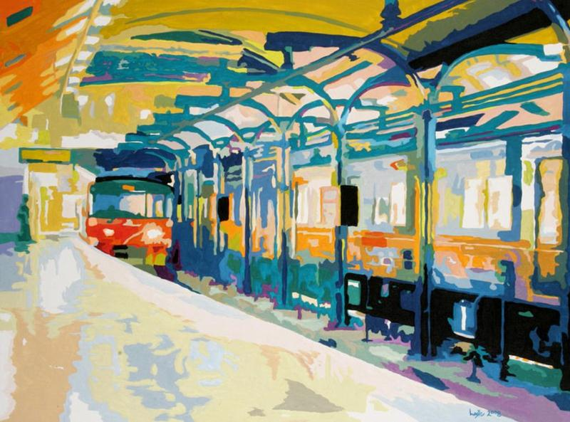
http://images.fineartamerica.com/images-medium-large/underground-bobby-logic.jpg
STIMULUS IMAGE 2
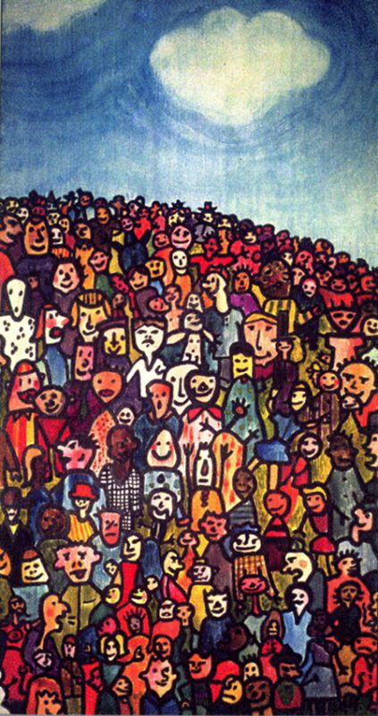
http://richardcardona.com/uploaded_images/population-726775.jpg

STIMULUS IMAGE 3
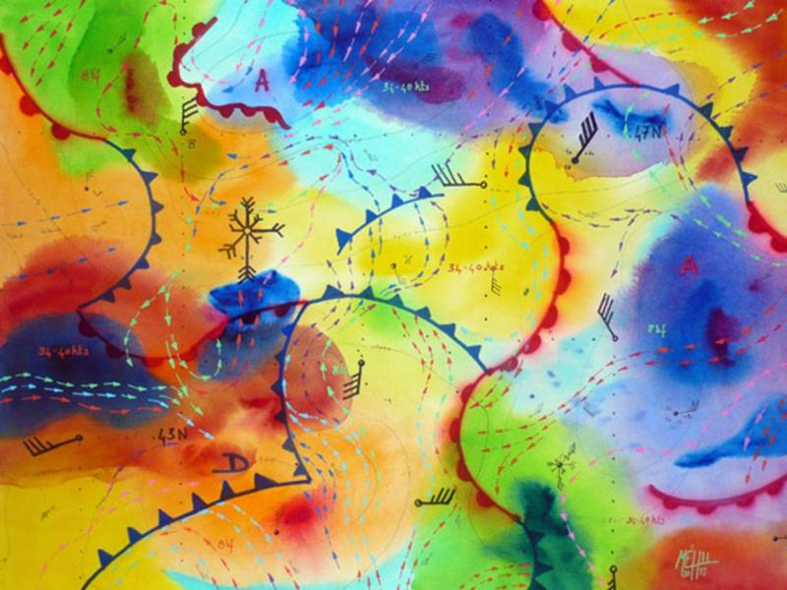
http://behance.vo.llnwd.net/profiles21/283126/projects/878227/628e7ddd47638825f42d91700458fb79.jpg
STIMULUS IMAGE 4
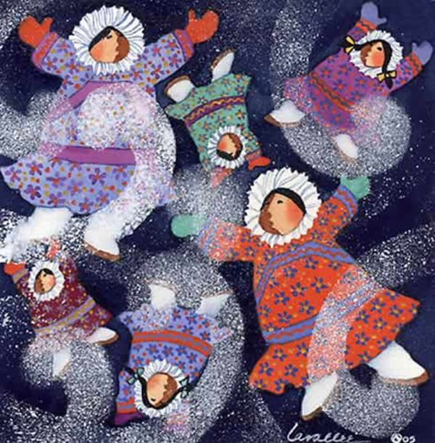
http://www.anniekaills.com/art/lavallee/eskimo_snow2.jpg

STIMULUS IMAGE 5
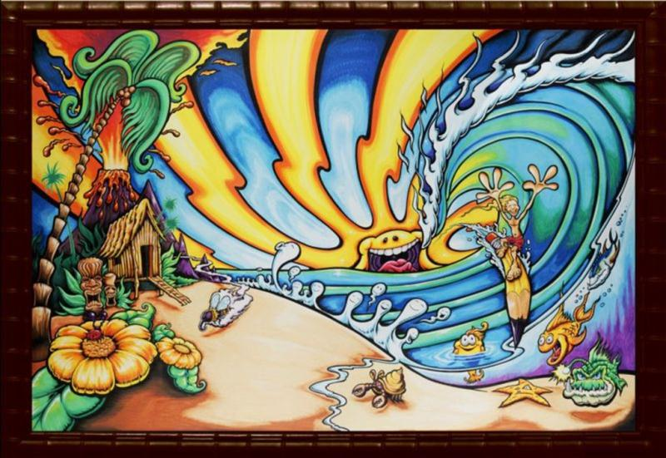
http://drewbrophy.com/site/wp-content/uploads/2010/03/walters-wave-painting-by-drew-brophy-mixed-media-on-wood-48-x-72-2009-rs.jpg

